**LEVEL 1**

**Story 1: Maria’s Promise**



There is a sari-sari store owner named Lena. She serves her customers every day with a smile.

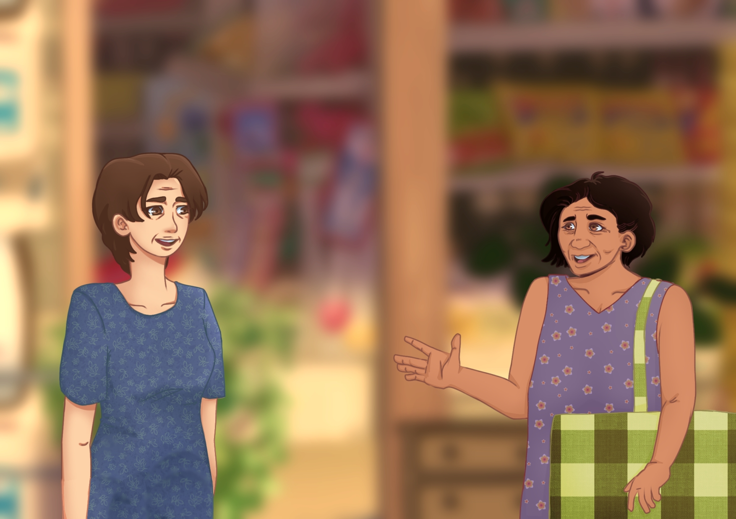

One afternoon, a regular customer and her trusted friend, Maria, came to Lena’s store and bought a pack of salt, one kilo of rice, and a pack of sugar.

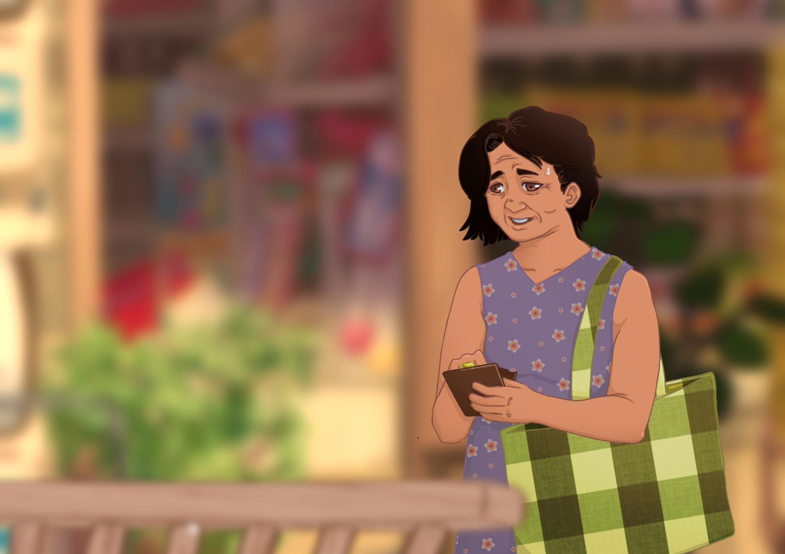

Lena prepared the items and told Maria about the total cost. Maria looked in her wallet but realized that she only had a large bill and Lena had no change for it.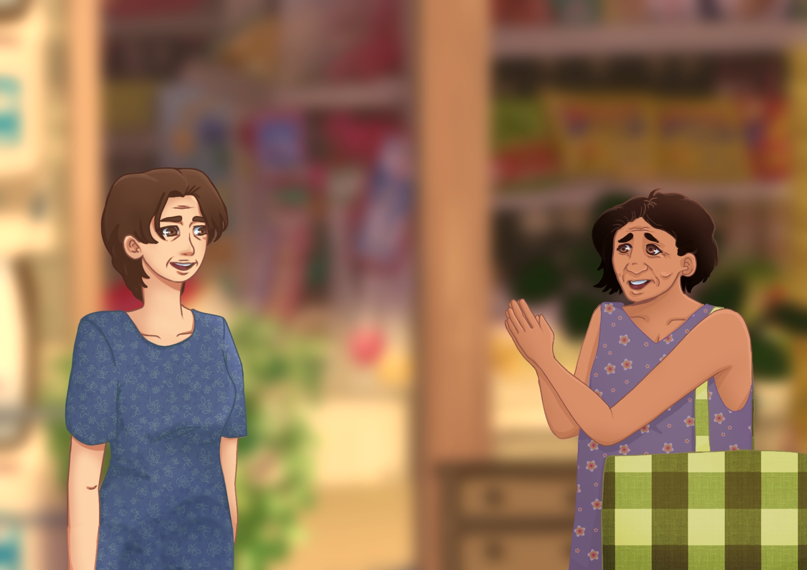

She apologized to Lena and said, “I’m sorry, I don’t have any small bill. I’ll come back later to pay you.” Lena smiled and nodded.

***(Question 1)***

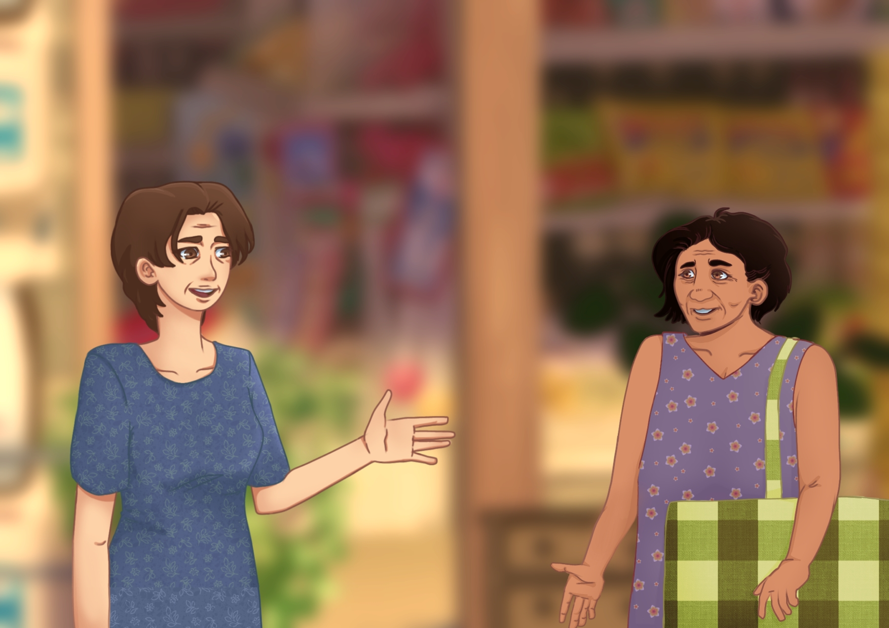

Lena agreed and said, “No problem, Maria. I am trusting you to return and pay later.” Maria smiled and thanked Lena.

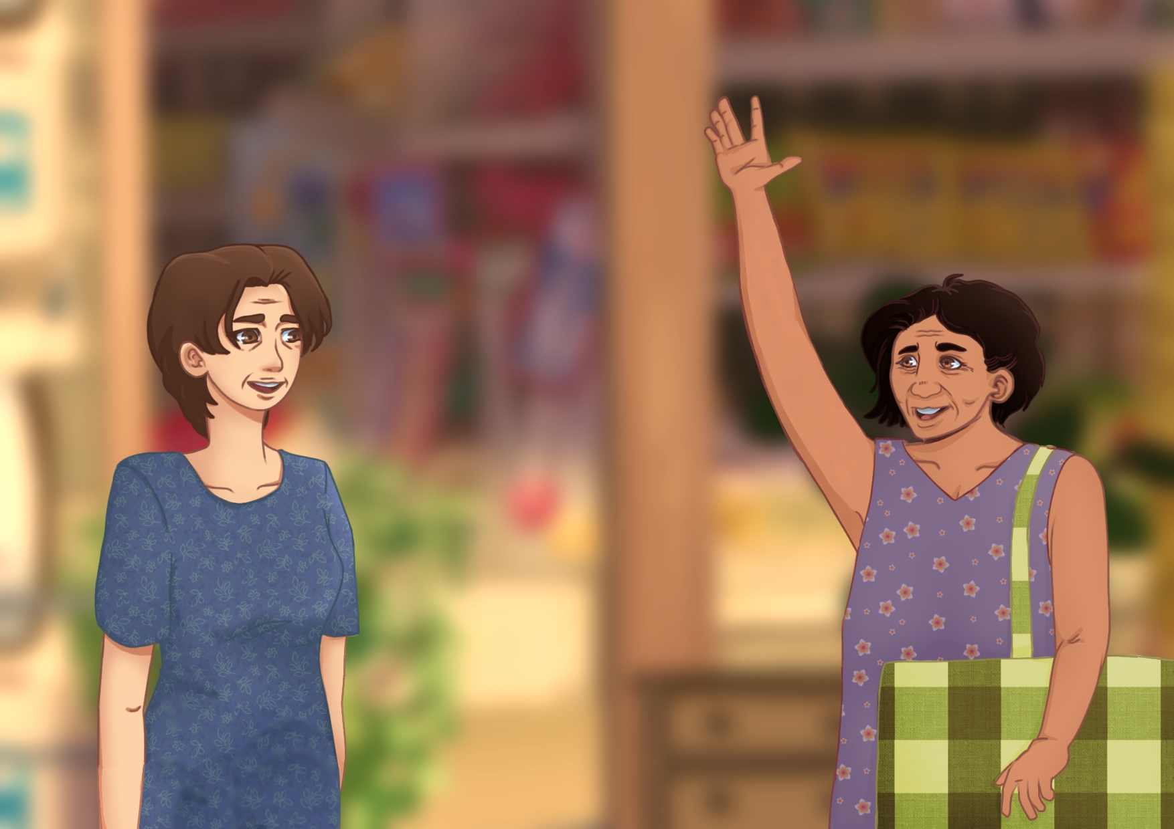

Few minutes later, Lena saw Maria approaching towards her store, smiling and raising her hand.

***(Question 2 & 3)***

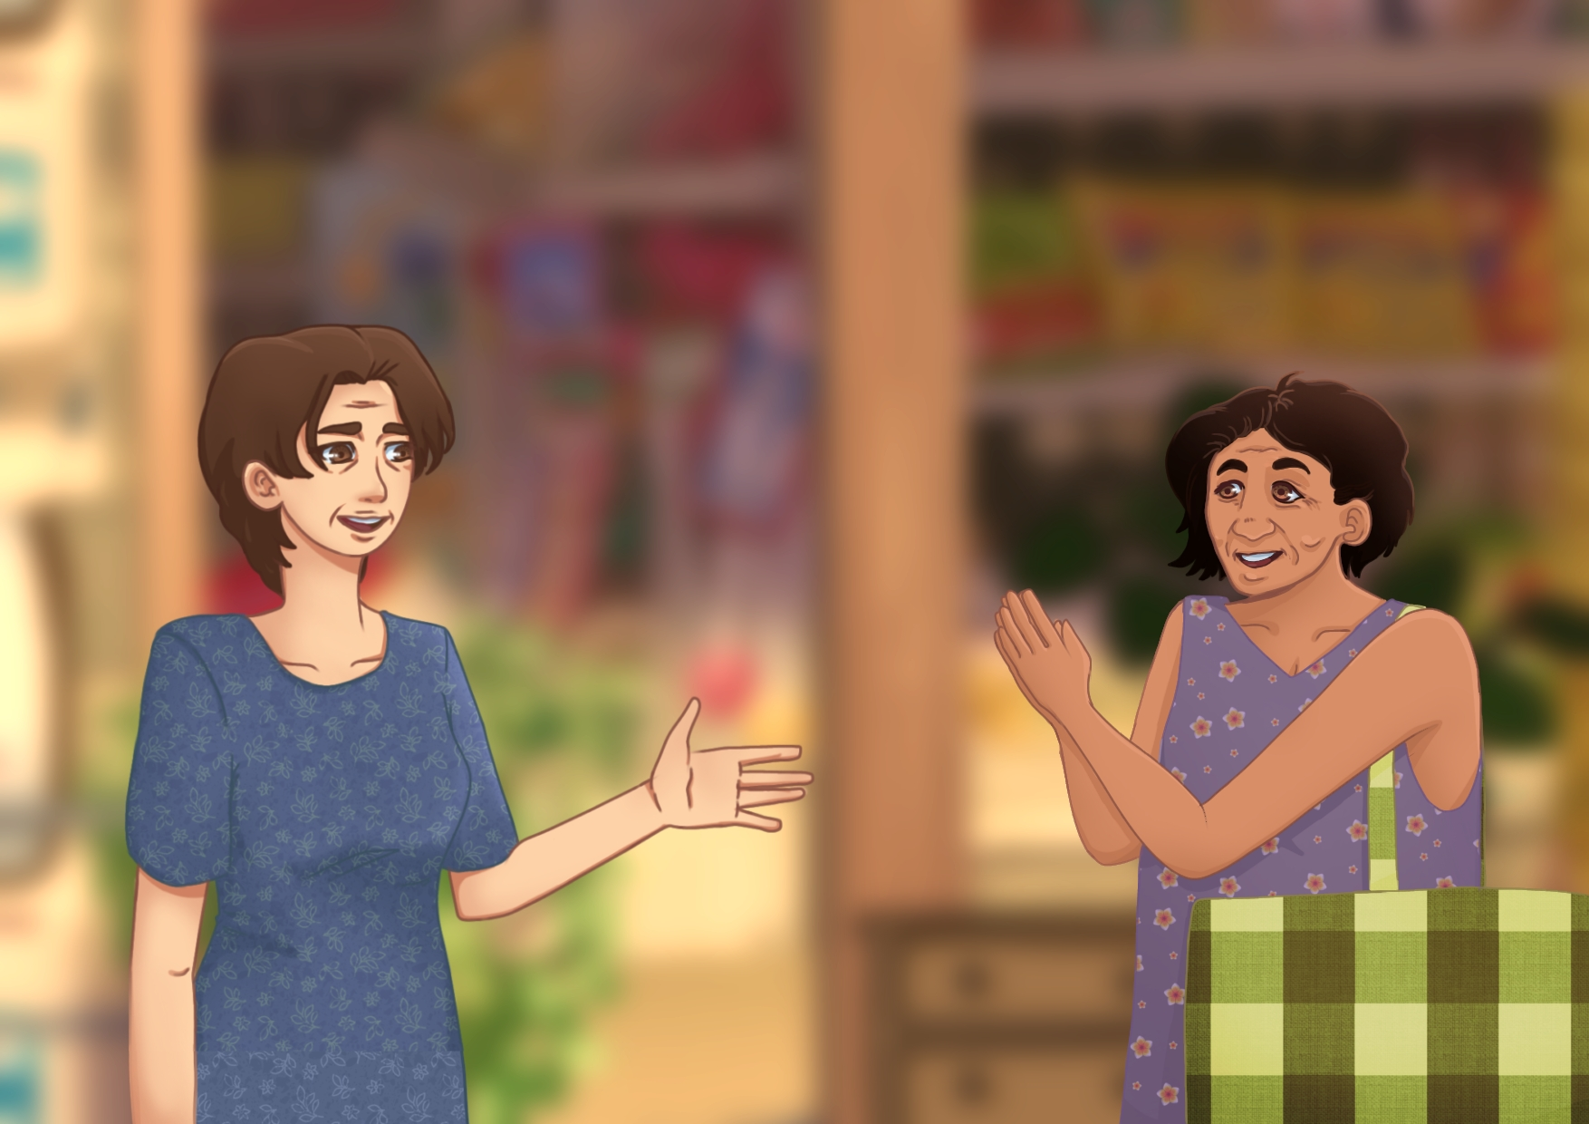

Maria went near and said, “Thank you for trusting me, Lena. This is my payment.” Lenanodded and told Maria, “No problem at all. I’m just glad you were able to pay.” Maria thanked her again, and Lena felt happy that she could trust her customer, knowing that trust is important in business.

**Story 2: Candice and Candies**

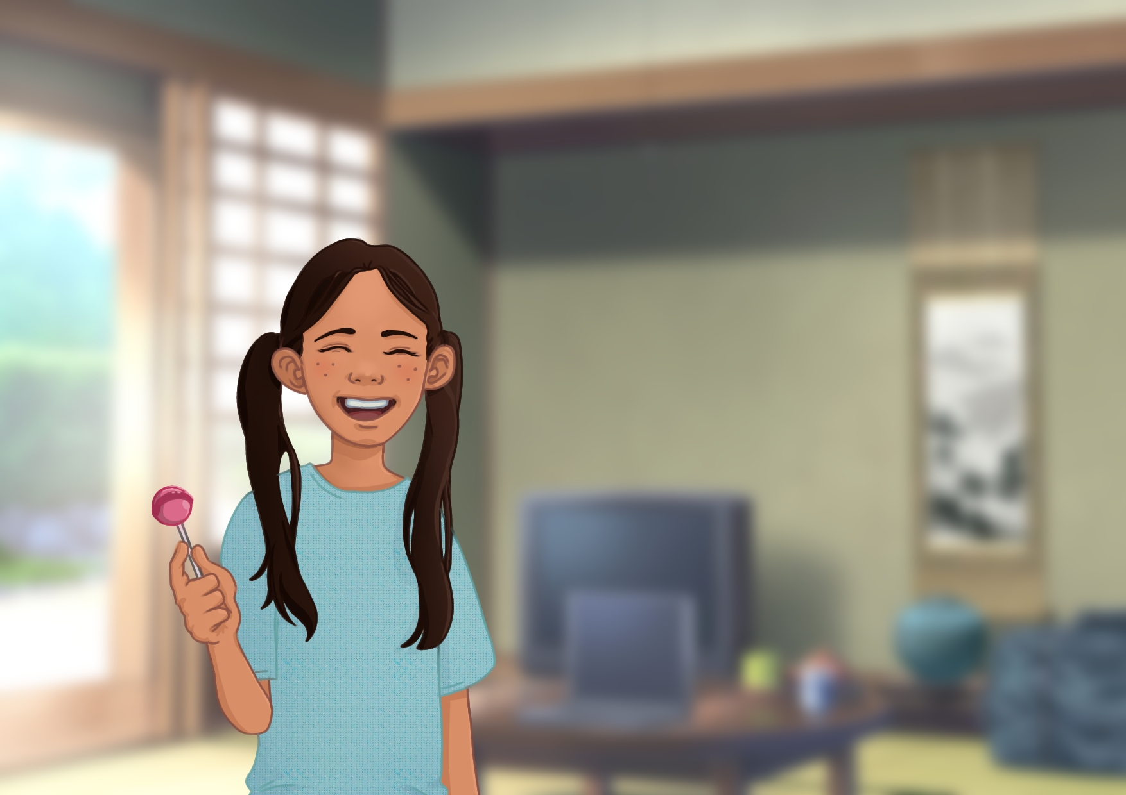

There was once a child who loved candies, her name is Candice. She eats candies for breakfast, lunch and dinner.

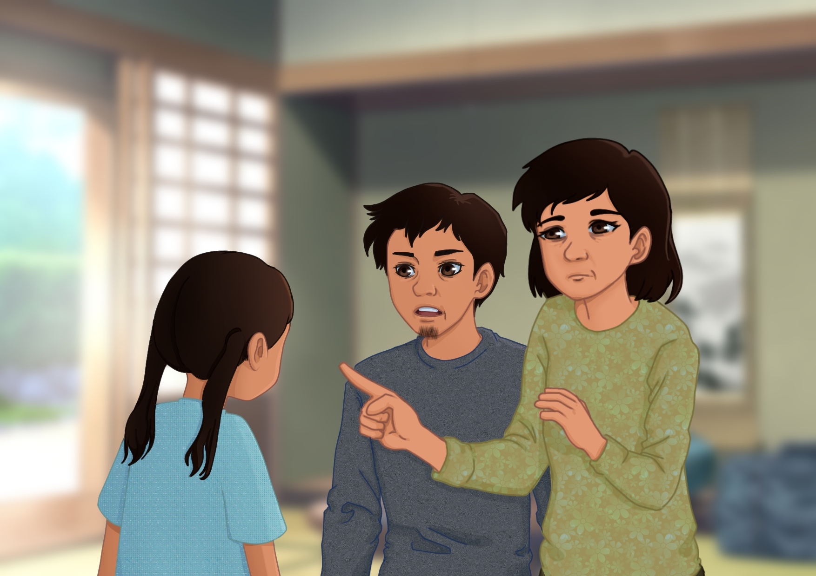

Her parents often warned her about the dangers of eating too many sweets. Her mother said, “*Candice, it’s not good to always eat sweets and candies*!”, but Candice just couldn’t resist.

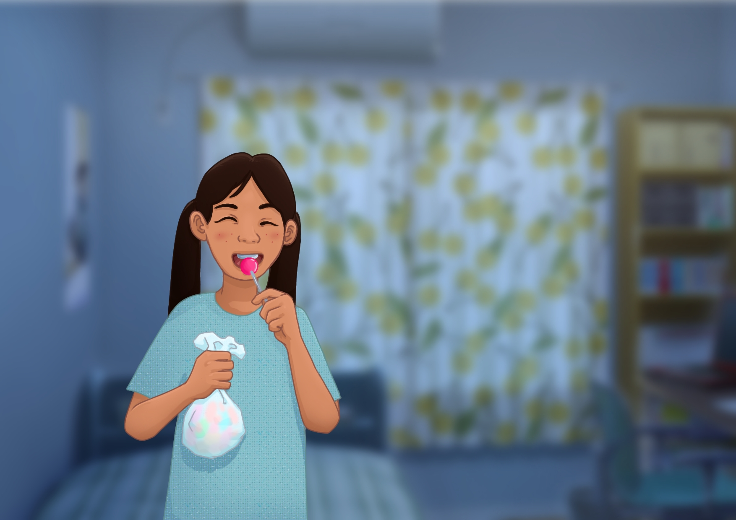

One day, Candice went to the sari-sari store to buy another pack of candies. At night, she ate all of the candies she bought and refused to brush her teeth.

***(Question 1)***

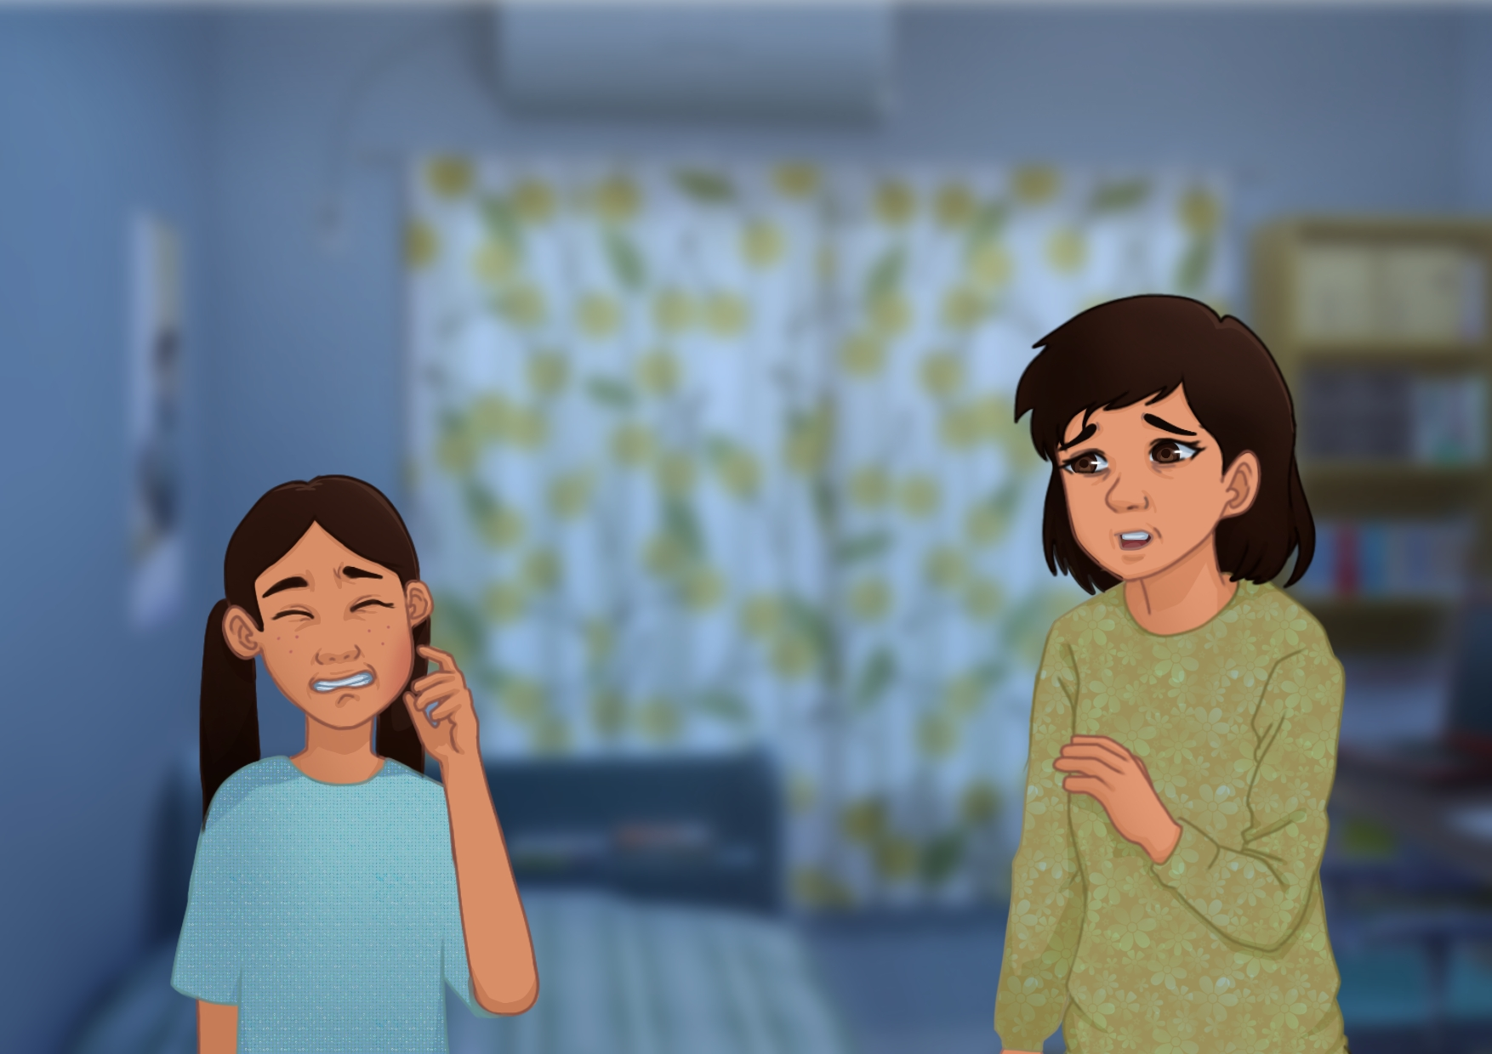

While sleeping, her cheek became swollen and she felt the pain in her teeth. Candice run towards her mother who said, “*I told you, it’s not good to eat too much sweets and candies without brushing your teeth. Let’s go to the dentist tomorrow and remember to brush your teeth from now on.”*

***(Question 2 & 3)***

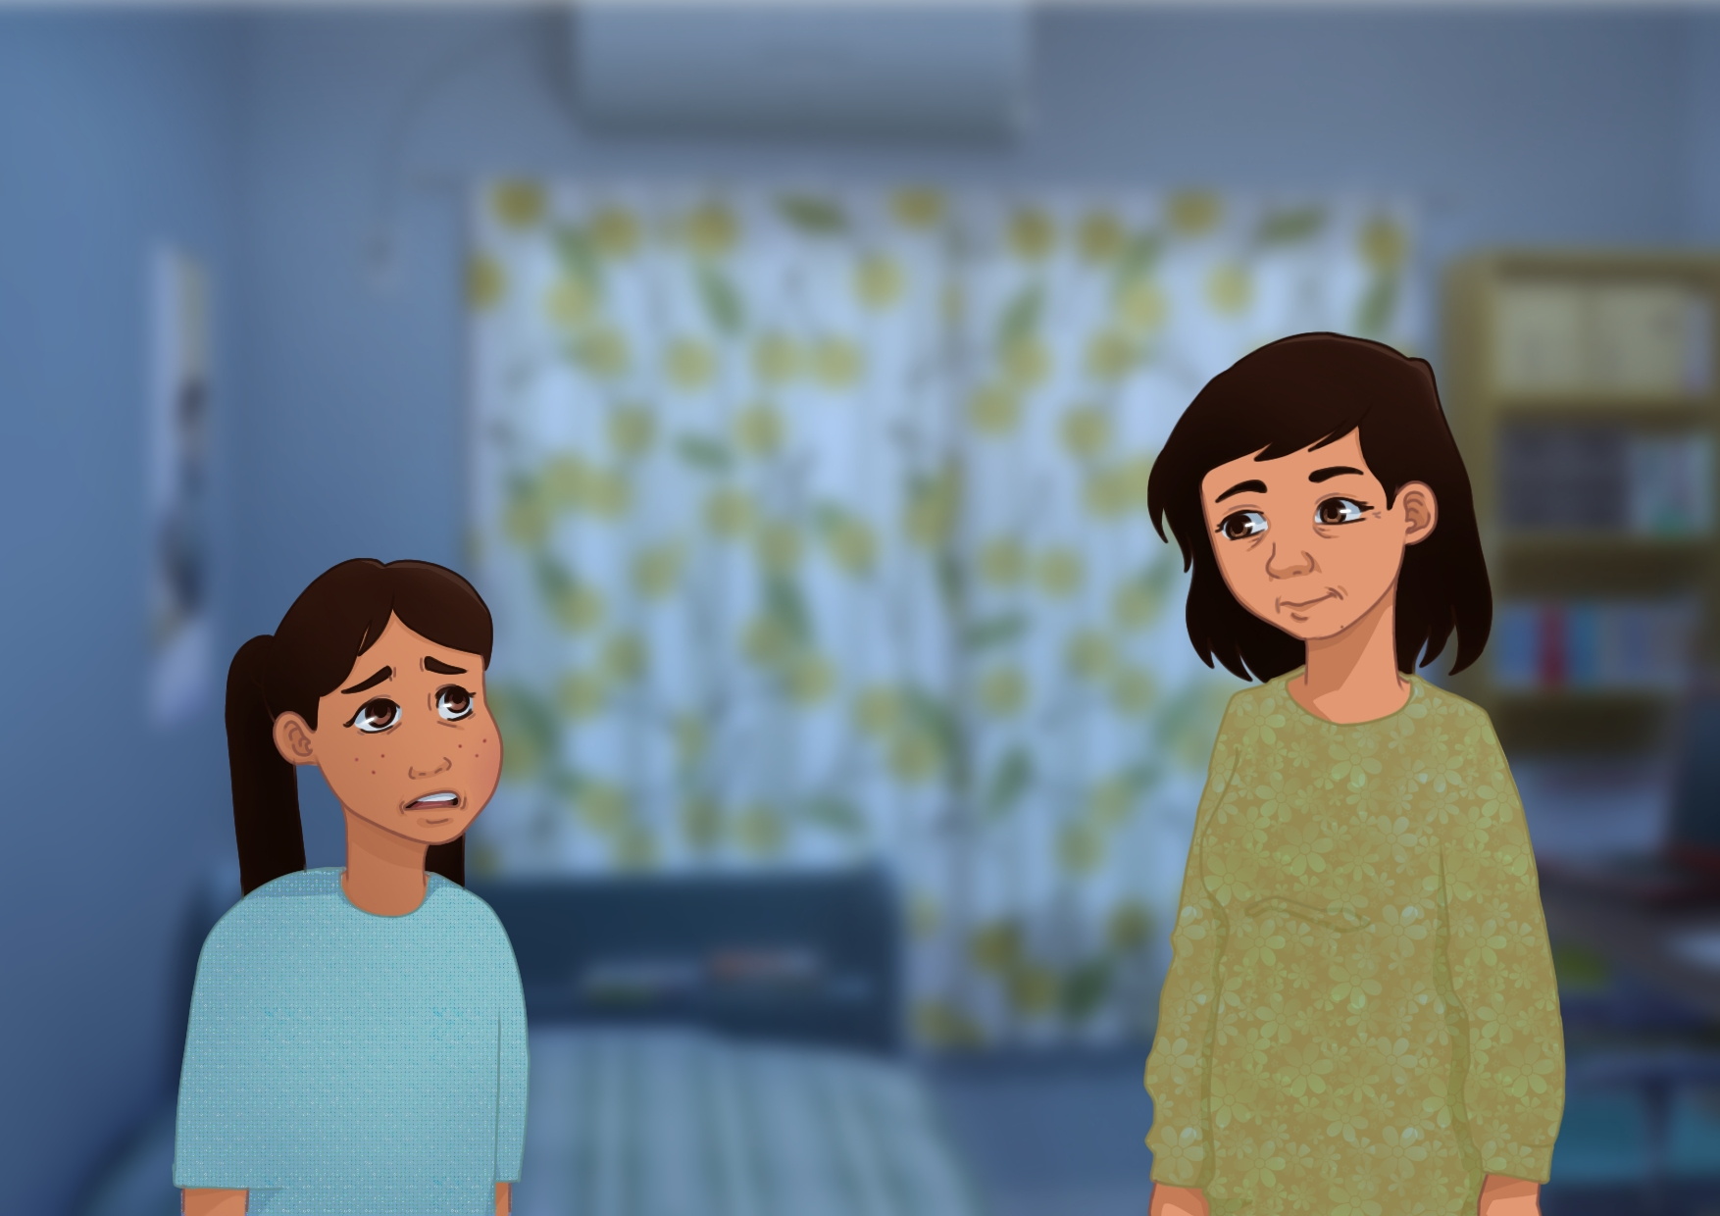

She nodded and said, *“I am sorry, mother. I will listen to you from now on.”*

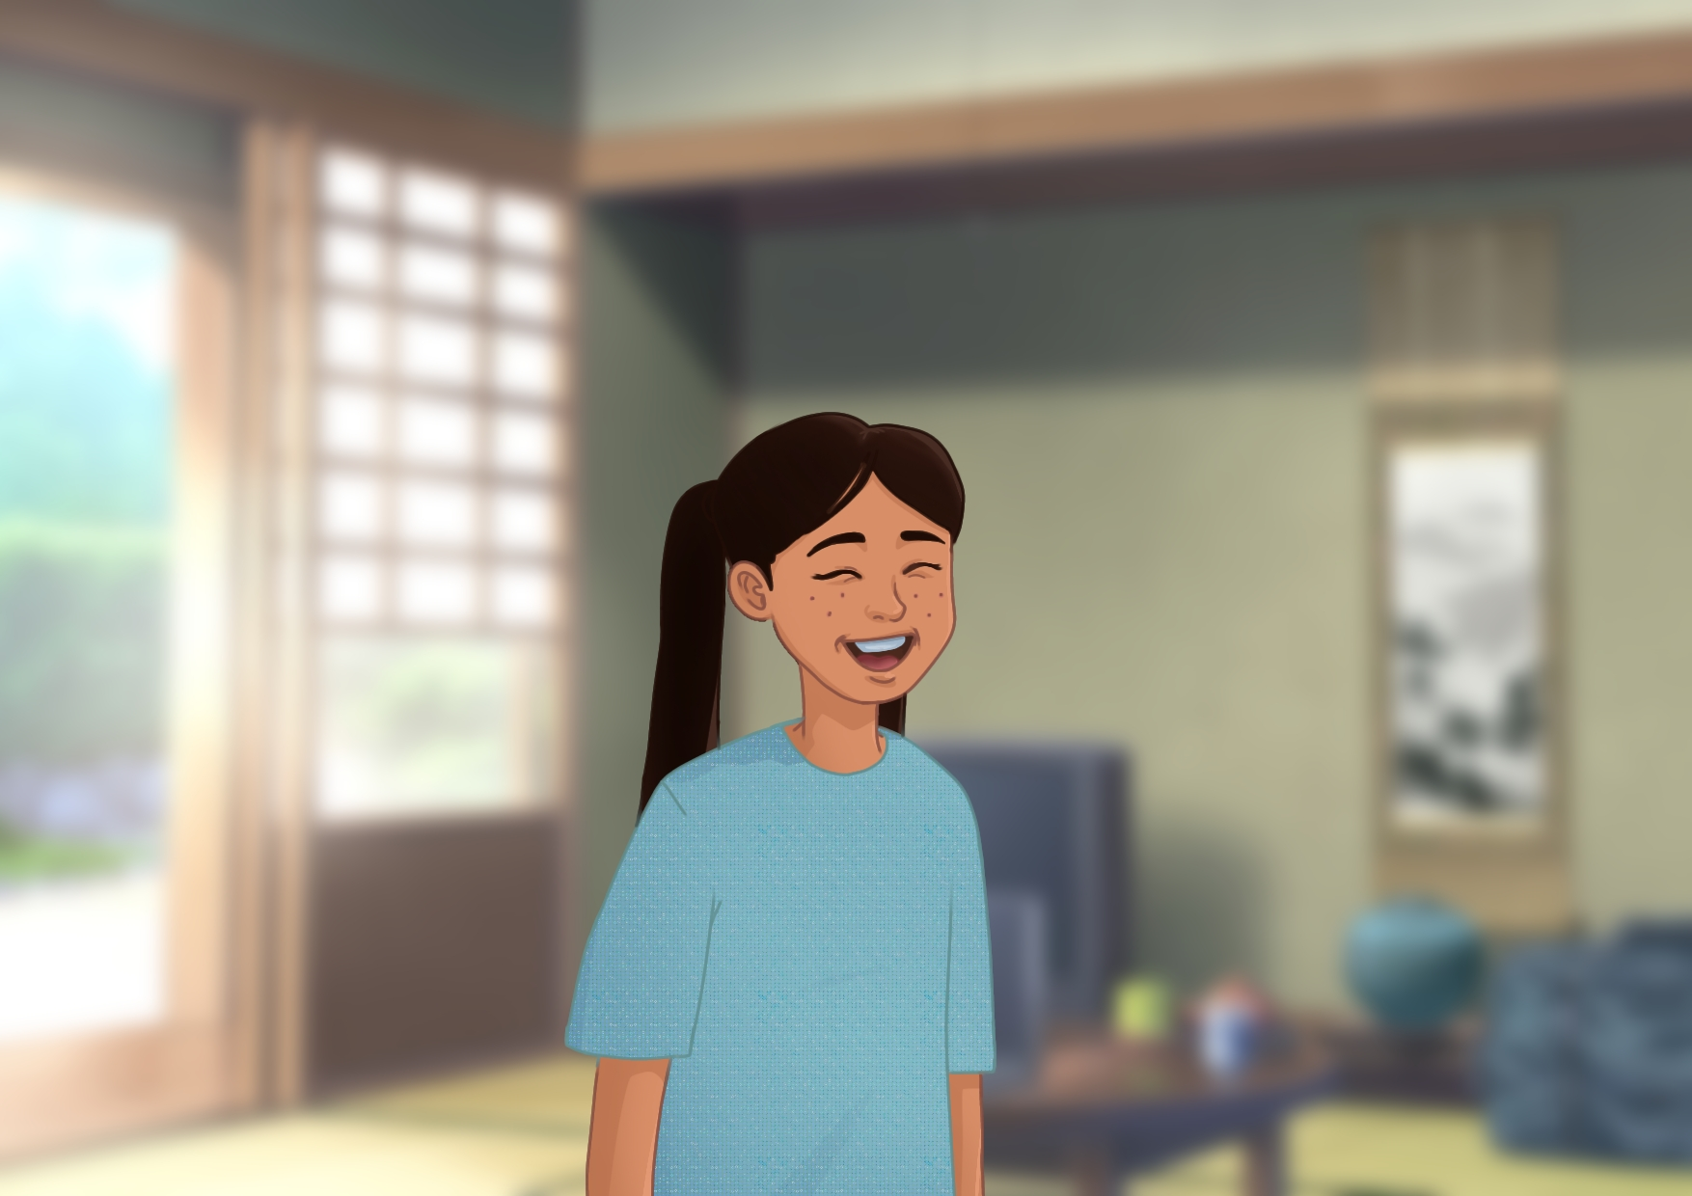

From that day on, she realized that it is important to avoid eating too much sweets and that it is important to brush her teeth afterward. Candice maintains the good health of her teeth and spreads the lesson to her friends.

**Story 3: Hannah, the Honest Vendor**



There is a vendor named Hannah. She is hardworking, honest, and always tries her best to serve her customers.

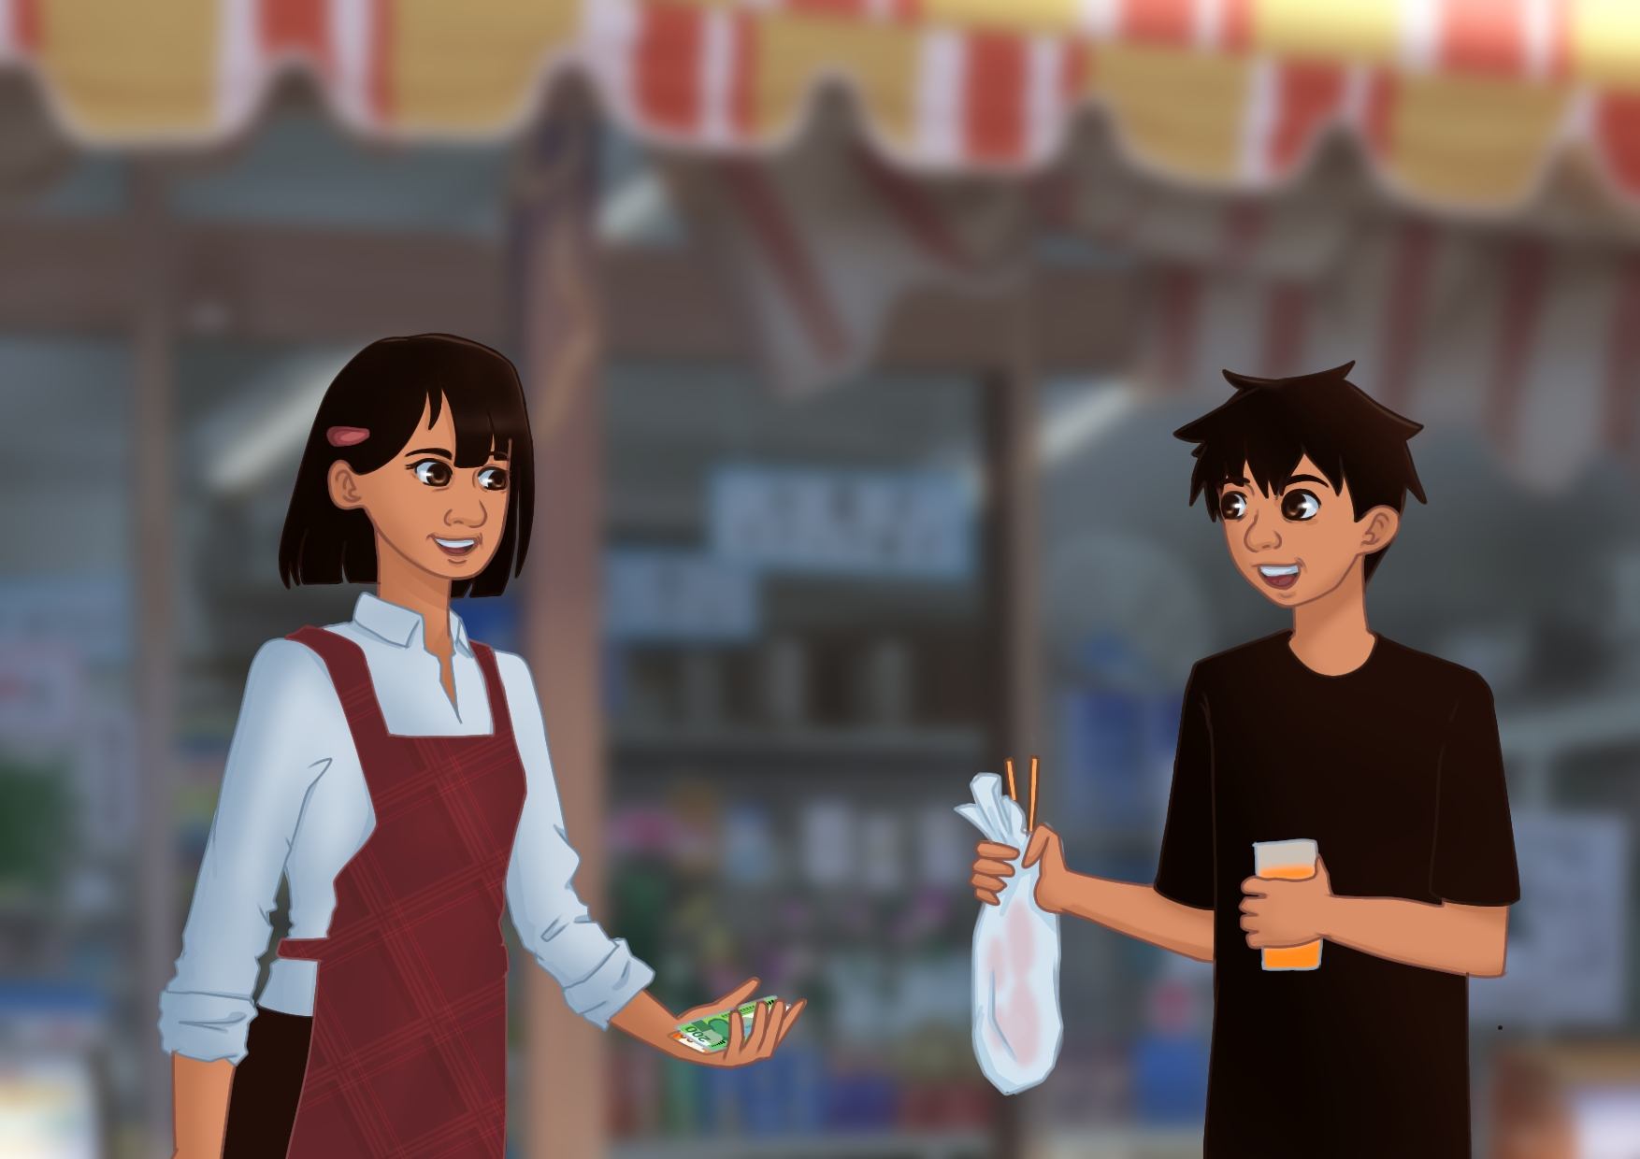

One day, Hannah was selling snacks at her stall when a customer bought two sticks of banana cue and a cup of juice. After Hannah gave the food to the customer, the customer quickly left.

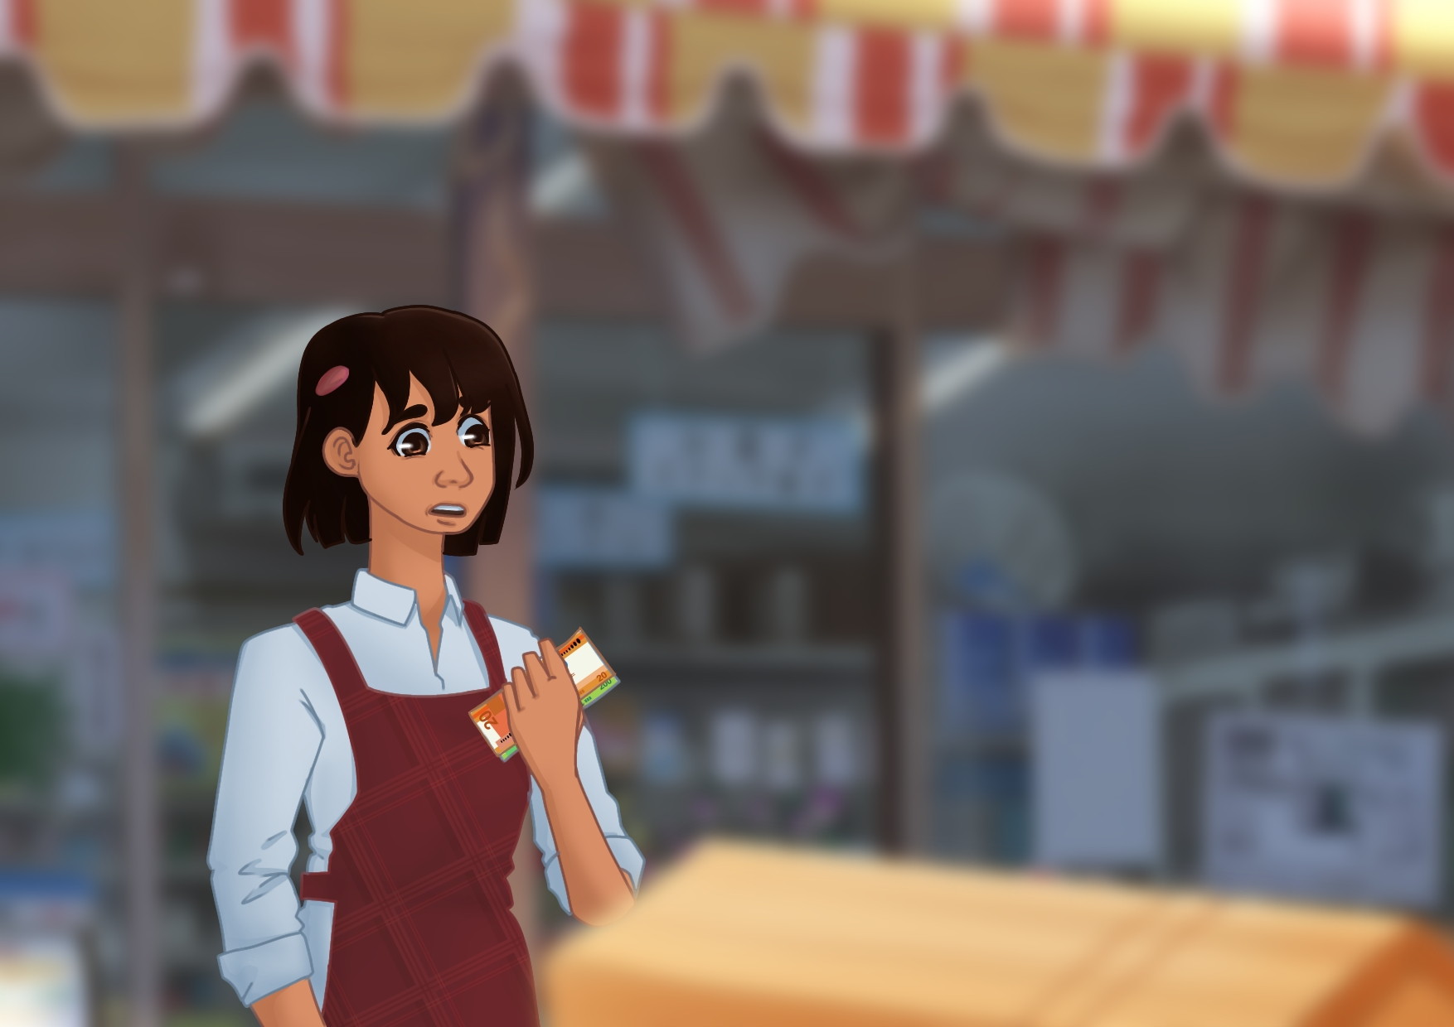

A few minutes later, Hannah noticed that the customer had accidentally paid her more than what was needed. The extra amount was a lot of money, and Hannah wasn’t sure if the customer realized the mistake.

***(Question 1)***

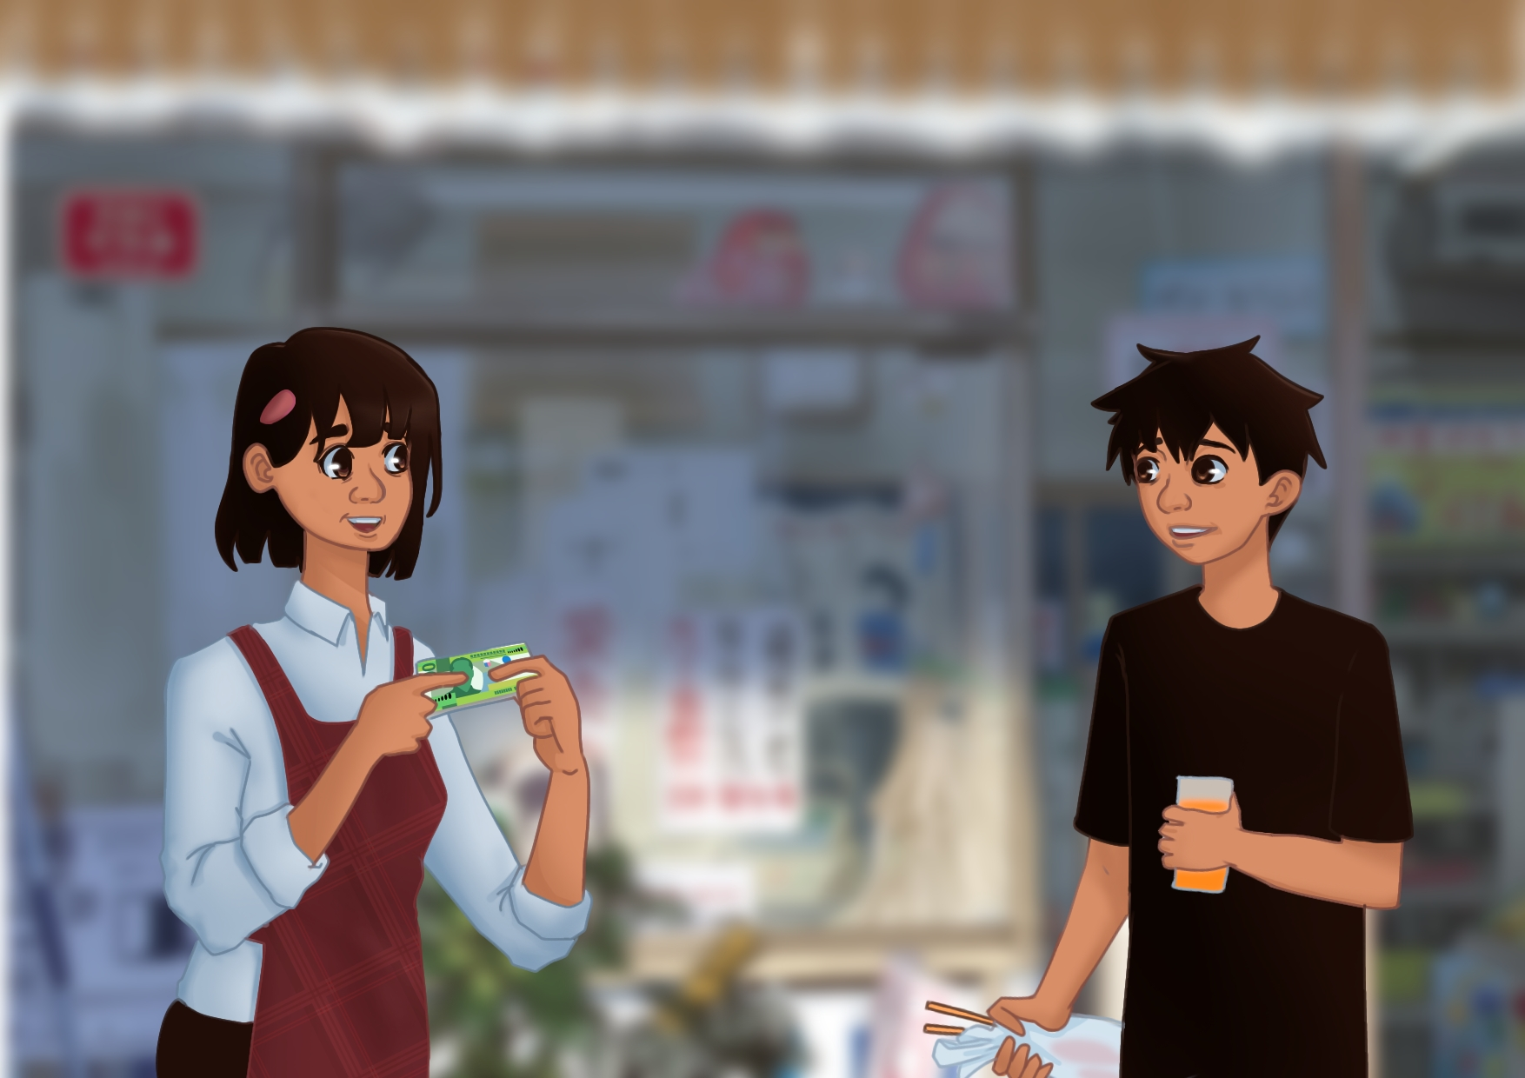

Hannah searched for the customer. Thankfully, the customer was still walking down the street when Hannah called out to him and said, *"Excuse me! You gave me more money than what was needed."* The customer smiled at Hannah who handed him the money.

***(Questions 2 & 3)***

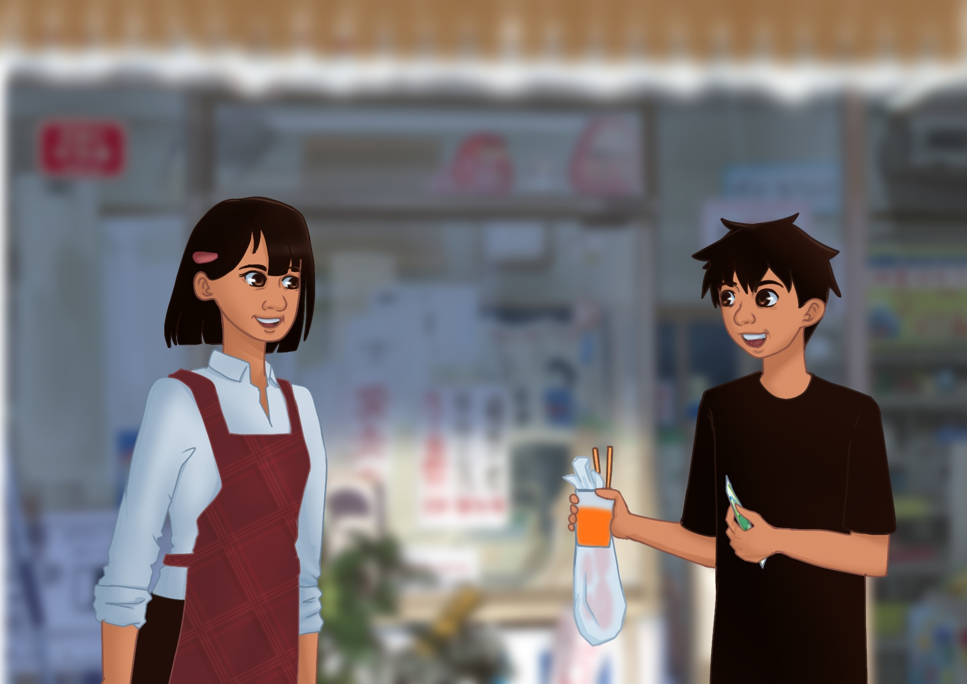

Hannah’s honesty made the customer smile and say, *"Thank you for being so honest. I will make sure to pay attention next time."*

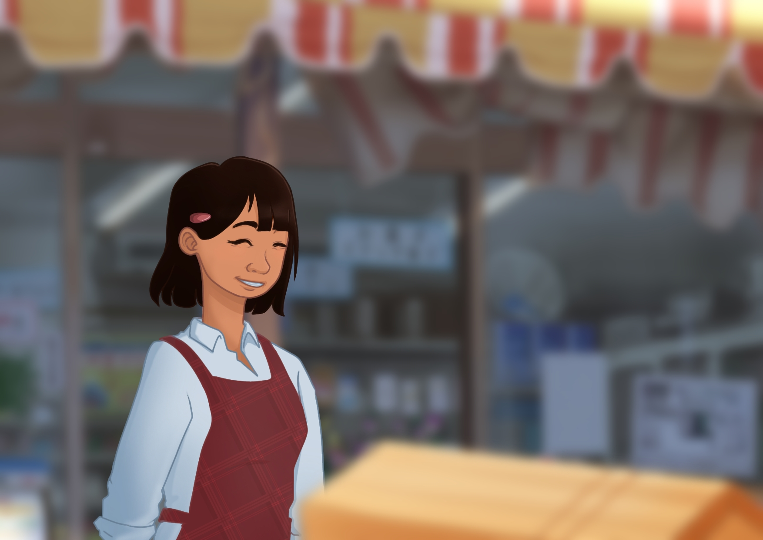

Hannah felt proud of her decision and happily went back to selling, knowing she had done the right thing. Now, she values the importance of honesty more.